Question 1: This data describes the outcome of a collision between two grocery carts, one empty (B) and one with groceries in it (A).  1a). Is this collision elastic, or inelastic? How do you know? |  | Grocery cart | Mass | Velocity before  the collision | Velocity after  the collision
 |  | A | 60 kg | 0.50 m/s | 0.25 m/s
 |  | B | 20 kg | 0 m/s | 0.75 m/s
Before the collision, cart B is not moving while cart A is approaching cart B. After the collision, both carts have a different velocity (cart A is moving at half its original velocity and cart B starts moving at 0.75m/s). This is an elastic collision because both cart B is bouncing off cart A, while cart A will slow down, so they are not sticking together like an inelastic collision, in which case both would have the same velocity after the collision.

1b). What does our mathematical model predict the mass of grocery cart B must be? 3 times larger.
1c). How many times larger was the magnitude of the change in velocity for cart B compared to cart A?
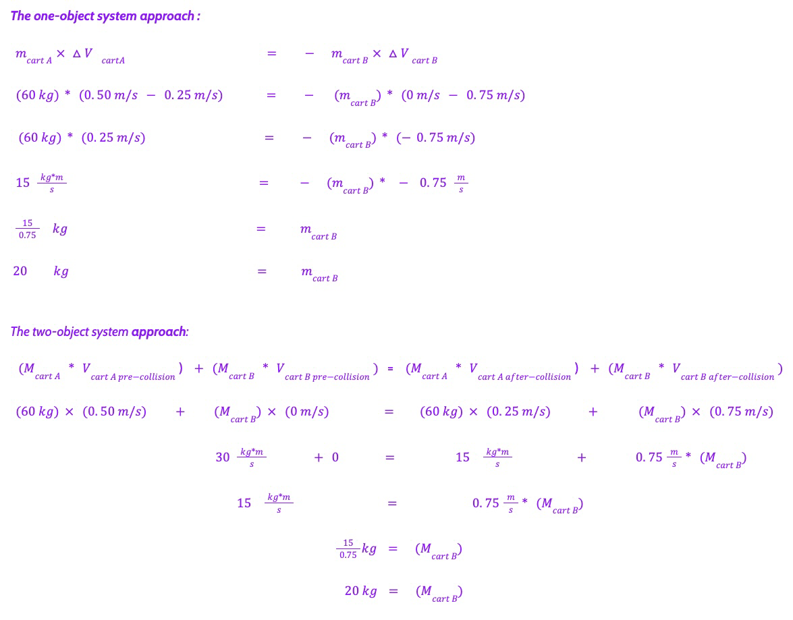

Question 2: A head on collision occurs between two vehicles. The smaller vehicle is 1500 kg and is moving at 30 mph before the collision. The larger car is 2250 kg and is moving at 30 mph in the opposite direction before the collision. The larger car comes to a stop as a result of the contact forces in the collision. For each graph, indicate whether it shows the expected velocity change in the smaller vehicle? (write yes or no for each, and explain why)

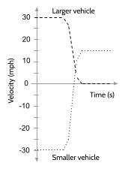 | 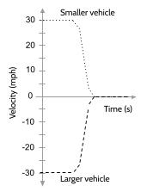 | 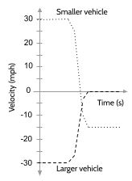 | 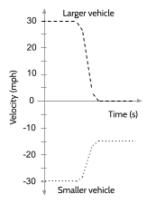
Yes. The graph shows that the smaller vehicle was moving at 30 mph and opposite to the larger vehicle. Once it collided with the larger vehicle, it started to move in an opposite direction at 15 mph, which is its final velocity, and shows a change in velocity of 45 mph. | No. This graph does not show the expected velocity change in the smaller vehicle. This graph shows that both vehicles came to a full stop after the collision. | Yes. The graph shows that the smaller vehicle was moving at 30 mph and opposite to the larger vehicle. Once it collided with the larger vehicle, it started to move in an opposite direction at 15 mph, which is its final velocity , and shows a change in velocity of 45 mph. | No. While this graph shows the correct magnitude for the final velocity of the smaller vehicle, it does not show the expected velocity change in the smaller vehicle. It shows that the smaller cart just slowed down from 30 mph to 15 mph, which is a change of only 15 mph.

Question 3: Switcher engines help move train cars around on tracks in train yards. To save time and fuel in this process, they sometimes uncouple a car they have been pushing, so it coasts along the track until it collides with a chain of stationary cars it needs to be connected to. When this happens the couplers on the end of the train cars automatically catch, and a longer chain of cars is formed. The collision sometimes results in the entire longer chain of cars moving forward in the direction of the push.

3a). Is this collision elastic, or inelastic? How do you know? This is an inelastic collision because the final velocity of the newly added car is the same as the final velocity of the chain of cars, as all of them move forward and together.

3b). How fast must a tanker car have been moving before such a collision if the following is true?
- The tanker car collides with and couples to 11 other tanker cars. You can assume that all 11 tanker cars together form a single object with mass ( 11 * m_{1 tanker car} ).
- The entire set of 12 cars ends up moving together at 0.2 m/s as a result of this collision. Every tanker car has a mass of 119,000 kg.
